Worksheet For Exercises From Chapter 26

Exercise 26.1

- Consider all the patterns that belong to Cluster 1. In general terms, what hidden unit activities characterize these patterns? Inspect the input unit values for these patterns. Do there appear to be any definite features? If so, list these features out. Inspect the input unit sums for these patterns. Is there any regularity to these sums?

- Consider all the patterns that belong to Cluster 2. In general terms, what hidden unit activities characterize these patterns? Inspect the input unit values for these patterns. Do there appear to be any definite features? If so, list these features out. Inspect the input unit sums for these patterns. Is there any regularity to these sums?

- Consider all the patterns that belong to Cluster 3. In general terms, what hidden unit activities characterize these patterns? Inspect the input unit values for these patterns. Do there appear to be any definite features? If so, list these features out. Inspect the input unit sums for these patterns. Is there any regularity to these sums?

- Consider all the patterns that belong to Cluster 4. In general terms, what hidden unit activities characterize these patterns? Inspect the input unit values for these patterns. Do there appear to be any definite features? If so, list these features out. Inspect the input unit sums for these patterns. Is there any regularity to these sums?

- Consider all the patterns that belong to Cluster 5. In general terms, what hidden unit activities characterize these patterns? Inspect the input unit values for these patterns. Do there appear to be any definite features? If so, list these features out. Inspect the input unit sums for these patterns. Is there any regularity to these sums?

- Inspect the single pattern that belongs to Cluster 6. Characterize it in the general terms that you have been using for the other clusters. Can you see any reason for this pattern belonging to its own cluster, and not belonging to Cluster 1?

- On the basis of the answers that you have generated for the questions above, can you provide a very general description of how the network solves this parity problem?

Exercise 26.2

- Relate Figure 26-1 to Table 26-4 as follows: examine the hidden unit activities for each cluster in that table. Use this information to circle the data points that belong to each cluster on the figure (which is provided again below).

- Using the smallest number of straight lines possible, draw decision regions in the figure above that separate the odd parity problems from the even parity problems.

- Remembering that the output unit of this network is a value unit, provide a general, qualitative account of how the two hidden units rearrange the input pattern space in such a way that the network solves this problem.

- Can you find any relationship between your answer to Question 3 above and your answer to Question 7 in Exercise 26.1?

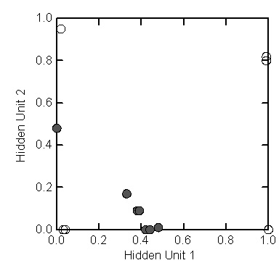

Exercise 26.3

- In the previous two exercises, you should have found that an even parity pattern produces an extreme value (i.e., extremely low or high) in both hidden units. In contrast, an odd parity problem generally produces an intermediate value in one hidden unit, and an extremely low value in the other. By examining the connection weights in the table above, can you explain how the network transforms the notion of parity into this simpler notion of hidden unit activity?

- By examining the connection weights above, can you come up with any account of why the one odd parity problem that falls into Cluster 6 differs from all of the other patterns that fall into Cluster 1?

